MODULE 4.2 Performing Text Analysis: Basic Approaches with Python
KEY TOOLS/PLATFORMS

Python
A programming language that is good for working with data.

pip
A package manager for Python

pyplot
Visualization function in the Python data science package, Pandas
HTRC Extracted Features
A downloadable dataset of text data and metadata extracted and abstracted from volumes in the HathiTrust Digital Library.

HTRC Feature Reader
A Python library for working with HTRC Extracted Features.

ACTIVITY: Identify the method Slide M4.2 - 6
What are the broad areas and methods used for the research examples we read earlier?
Project summaries: http://go.illinois.edu/ddrf-research-examples
 | Broad area | Specific method
Rowling and “Galbraith”: an authorial analysis
Significant Themes in 19th Century Literature
The Emergence of Literary Diction

ACTIVITY: View adjectives in Extracted Features files Slide M4.2 - 26
- Go to your PythonAnywhere dashboard and click on the “Browse files” button to check if all files and directories are in place
- On your “Files” page, you will see your directories on the left and your files on the right.
- You should have two directories “1930/” and “1970/” listed on the left.
- Click on each directory.
- There should be 16 json.bz2 files in the “1970/” directory that correspond to the volumes in the poli_science_DDRF workset atn 5 json.bz2 files in the “1930/” directory of Presidential Papers volumes from the 1930s.
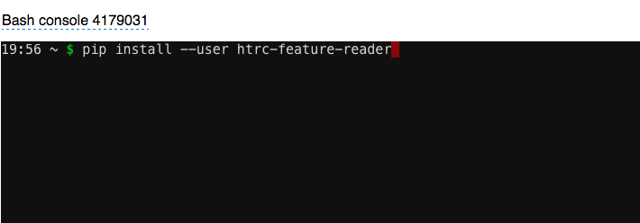
- Open the Bash console.
- Install the Feature Reader Library by typing:
pip install --user htrc-feature-reader
- Hit enter.
- From the Bash shell, run the script. Enter command (remember to use the tab key to help you automatically complete the file names):
python top_adjectives.py 1970
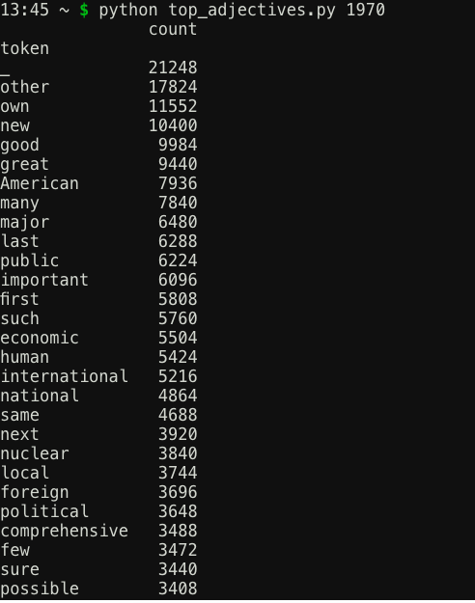
- Hit Enter. The results will be printed out directly in the window.

ACTIVITY: Now you try! Slide M4.2 - 32
- Compare the adjectives used by presidents in the 1970s with those used in the 1930s.
- Work and discuss with your neighbor.
  - How do you need to change your command?
  - What differences do you see? Similarities?

Challenge | Try modifying the script to search verbs or another part of speech.  (Hint: Don’t forget the Penn Tree Bank – you can find it here: https://www.ling.upenn.edu/courses/Fall_2003/ling001/penn_treebank_pos.html )

ACTIVITY: Visualize word trends Slide M4.2 - 36
- Open the Bash console
- Enter the command “python word_count.py”
- Click the “PythonAnywhere” logo to go back to the home screen and go to your Files.

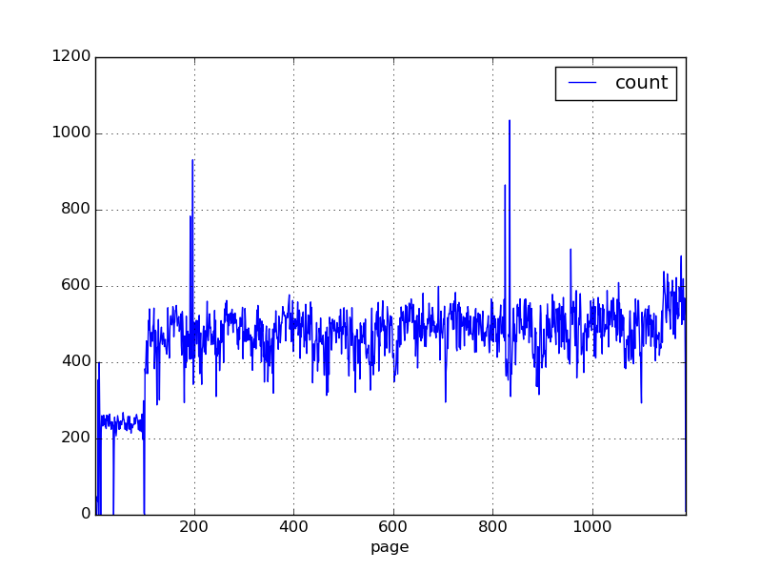
- The “words.png” file should be in your Files. Click on the download icon to the right of the file name to open the file.

ACTIVITY: Now you try! Slide M4.2 - 40
- Can you modify the script to look at another volume?

