Digging Deeper Reaching Further
Libraries Empowering Users to Mine the HathiTrust Digital Library Resources

GETTING SET UP

Setup Checklist (detailed instructions below)
- Download activity_files.zip
- Create an HTDL account
- Create an HTRC Analytics account

- Create a PythonAnywhere account and upload activity file
- Verify you are using an internet browser that is not Internet Explorer

Download activity files
http://go.illinois.edu/ddrf-curriculum
  - Find the link to Activity Files under the “Set-up & Exercise Files” section.
  - Download the files by clicking on the link.
  - The folder will download as a zipped file to your computer. Do not unzip it!
    - If using Safari on a Mac, the activity_files.zip file may be automatically unzipped into a folder when downloaded. Compress the folder into a zip file again by right clicking on the downloaded folder and selecting “Compress ‘activity_files.”

Create an HTDL account
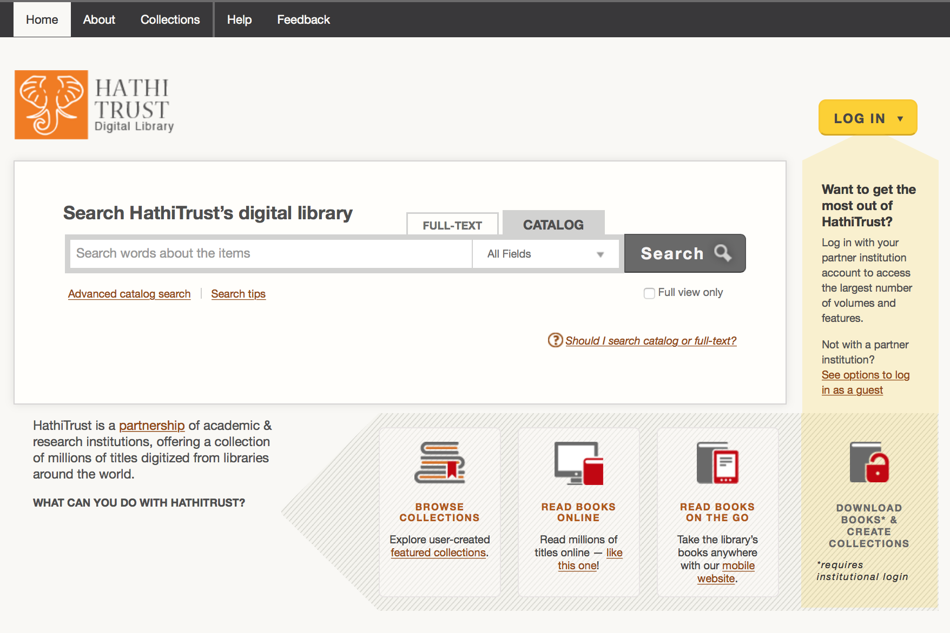
https://www.hathitrust.org
- Click “LOG IN” in the top right corner.
- A log in window will appear.
- If you are affiliated to an HT partner institution, select your institution and then follow the directions for institutional log in.
- If you are not affiliated to an HT partner institution, you can log in as a guest.
  - Click on “See options to log in as a guest” in the log in window.
  - You will be directed to a new page where you can log in with a Google, Facebook, Twitter, AOL, LinkedIn, Windows Live (Hotmail), Yahoo!, or University Michigan Friend Account.
  - Click on an option of your choice and follow the directions.
This work is licensed under a Creative Commons Attribution-NonCommercial 4.0 International License

Create an HTRC Analytics account
http://analytics.hathitrust.org/
- Click “Sign Up” in the top right corner.
- Use an email address from an academic institution and follow security guidelines for the password.
- Activate your account from the link you will be sent via email.

NOTE: Make sure to create accounts in both HTDL and HTRC Analytics. These are two separate things and you will need both accounts to do the activities.

Create a PythonAnywhere account and upload activity files
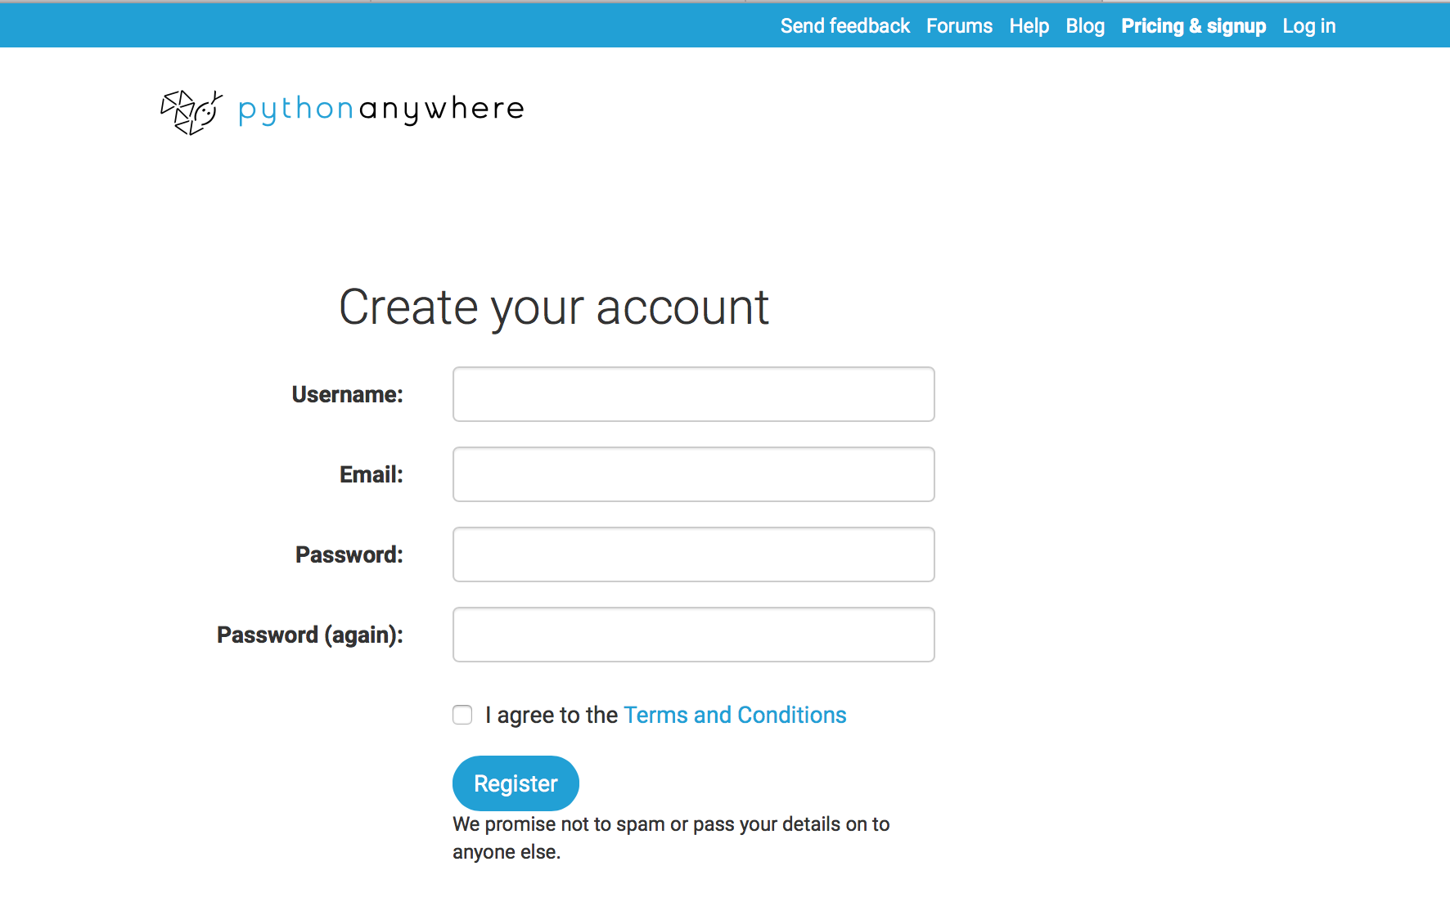
https://www.pythonanywhere.com
- Click “Pricing & signup” in the top right corner.
- Click “Create a Beginner account.”
- Enter your information. Make note of your username.
- Click “Register.”

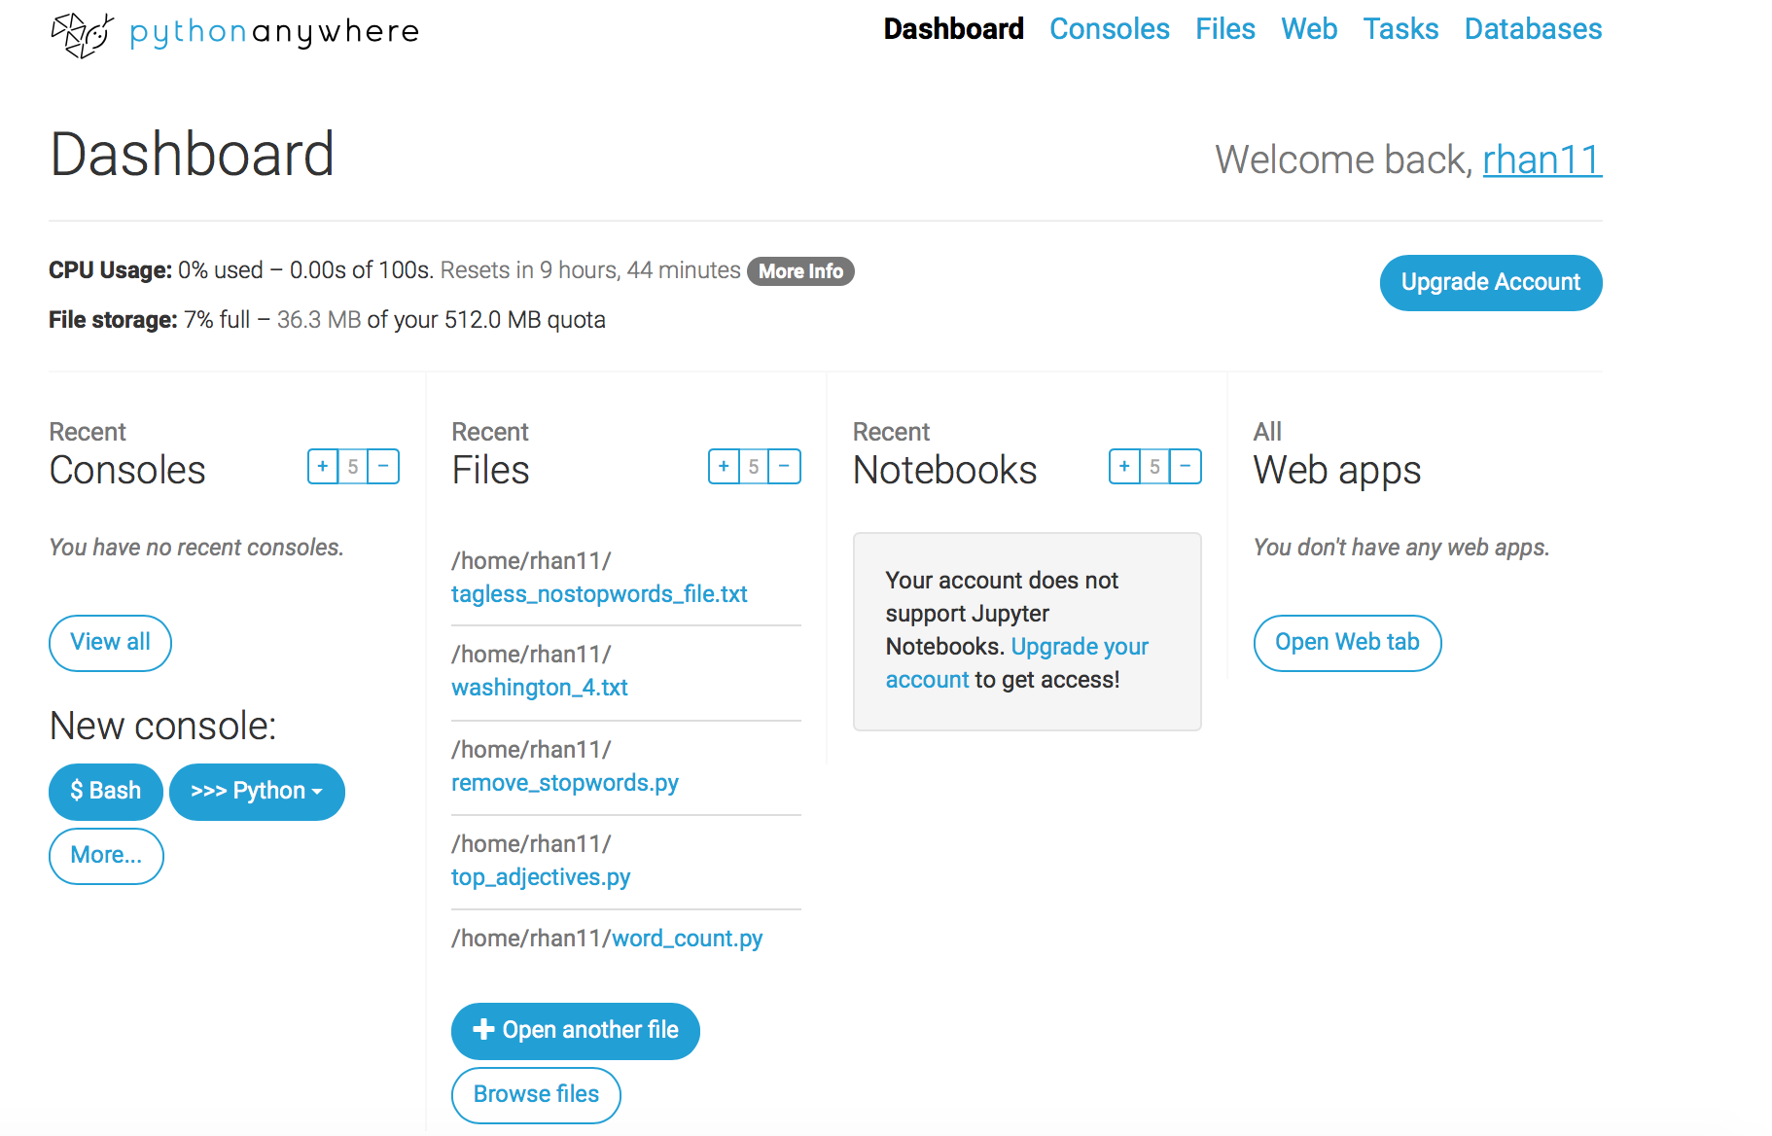
- Once logged in, you’ll see options for Consoles and Files on your dashboard and in the top right corner of the page, which will be used in this workshop.

- Upload the activity_files.zip file that you downloaded:
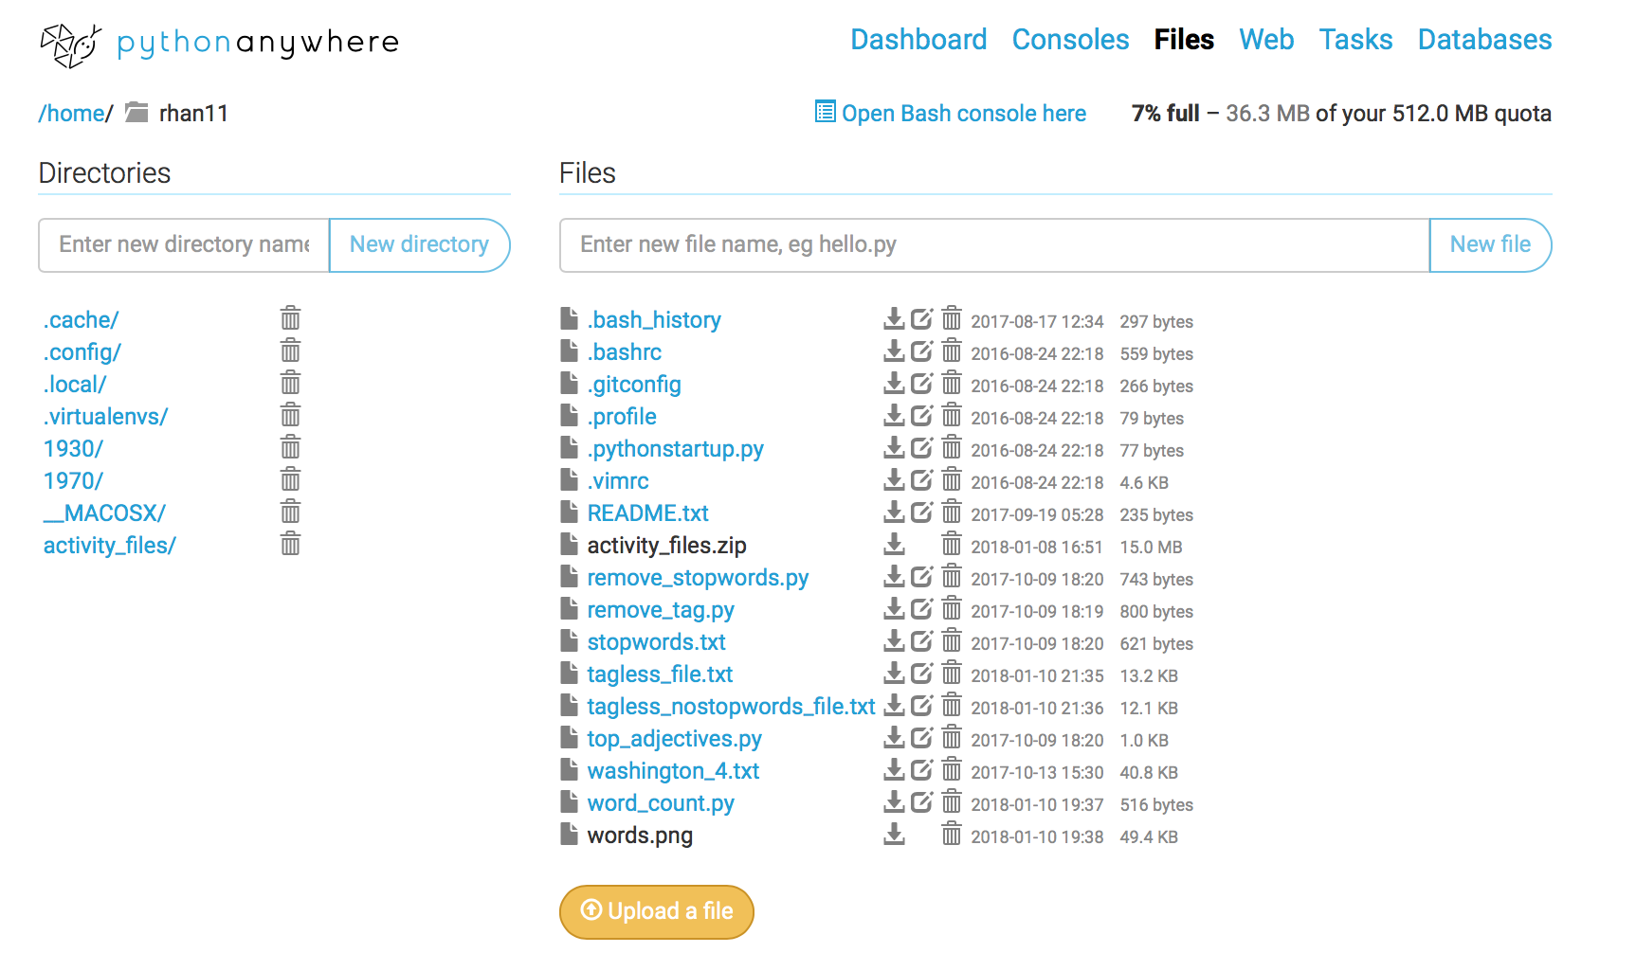
  - Click on the “Browse Files” button in the “Files” column on your dashboard, or click on the “Files” option in the top right corner.
  - Click on the “Upload a file” button near the bottom of the page and locate the activity_files.zip file on your computer to upload.

MODULE 1 Introduction
KEY TOOLS & PLATFORMS

HathiTrust
A library consortium founded in 2008. HathiTrust is a community of research libraries committed to the long-term curation and availability of the cultural record.

The HathiTrust Digital Library (HTDL)
HathiTrust’s digital preservation repository and access platform for public domain and in-copyright content from a variety of sources, including Google, the Internet Archive, Microsoft, and in-house partner institution initiatives. Overall, the content mostly consists of digitized books from libraries.

The HathiTrust Research Center (HTRC)
HathiTrust’s center for facilitating computational, scholarly research using the 16+ million volumes in the HathiTrust Digital Library. The HTRC provides mechanisms for non-consumptive access to content in the HathiTrust corpus, as well as tools for computational text analysis.

ACTIVITY: Explore sample research projects Slide M1 - 8
In pairs or small groups, review the summarized research projects available at
http://go.illinois.edu/ddrf-research-examples.
Then discuss the following questions:
- How do the projects involve change over time, pattern recognition, or comparative analysis?
- What kind of text data do they use (time period, source, etc.)?
- What are their findings?
MODULE 2.1 Gathering Textual Data: Finding Text
KEY TOOLS & PLATFORMS

HT Collection Builder
An interface for creating collections via the HathiTrust Digital Library.

HTRC Analytics
An interface for working with HTRC worksets, which are collections of text from HathiTrust that can be analyzed using the non-consumptive tools and environments in HTRC Analytics.

ACTIVITY: Evaluating different sources for textual data Slide M2.1 - 9
If we are building a corpus for political history, what are the strengths and weaknesses of each of the following broad sources for textual data? Please discuss and take some notes in the chart below.

 | Strengths | Weaknesses
Vendor database | Potentially higher quality  Depth of coverage | Copyright restrictions  Some vendors do not allow text analysis  Much of the OCR is dirty OCR
Library and archives digital collections | Unique collections  Free | They have fewer resources to make these things available, so less content, potentially low quality
Social media | Quantity of content  Ease of access | Large files  Data is from a subset of the population  Difficult to determine sarcasm  Spelling errors / Acronyms

ACTIVITY: Building and uploading a workset Slide M2.1 - 17
Let’s create a workset for a political science student. As an example, we’ll do an advanced full-text search for volumes that contain both “public papers” and “United States” in their titles
- Make sure you are still logged in to the HTDL: https://www.hathitrust.org/
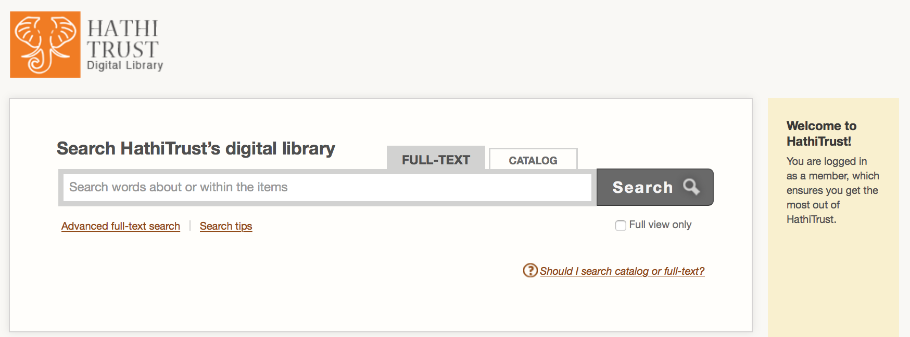
- Click the “FULL-TEXT” tab to search in full text.
- Click “Advanced full-text search” under the search bar.

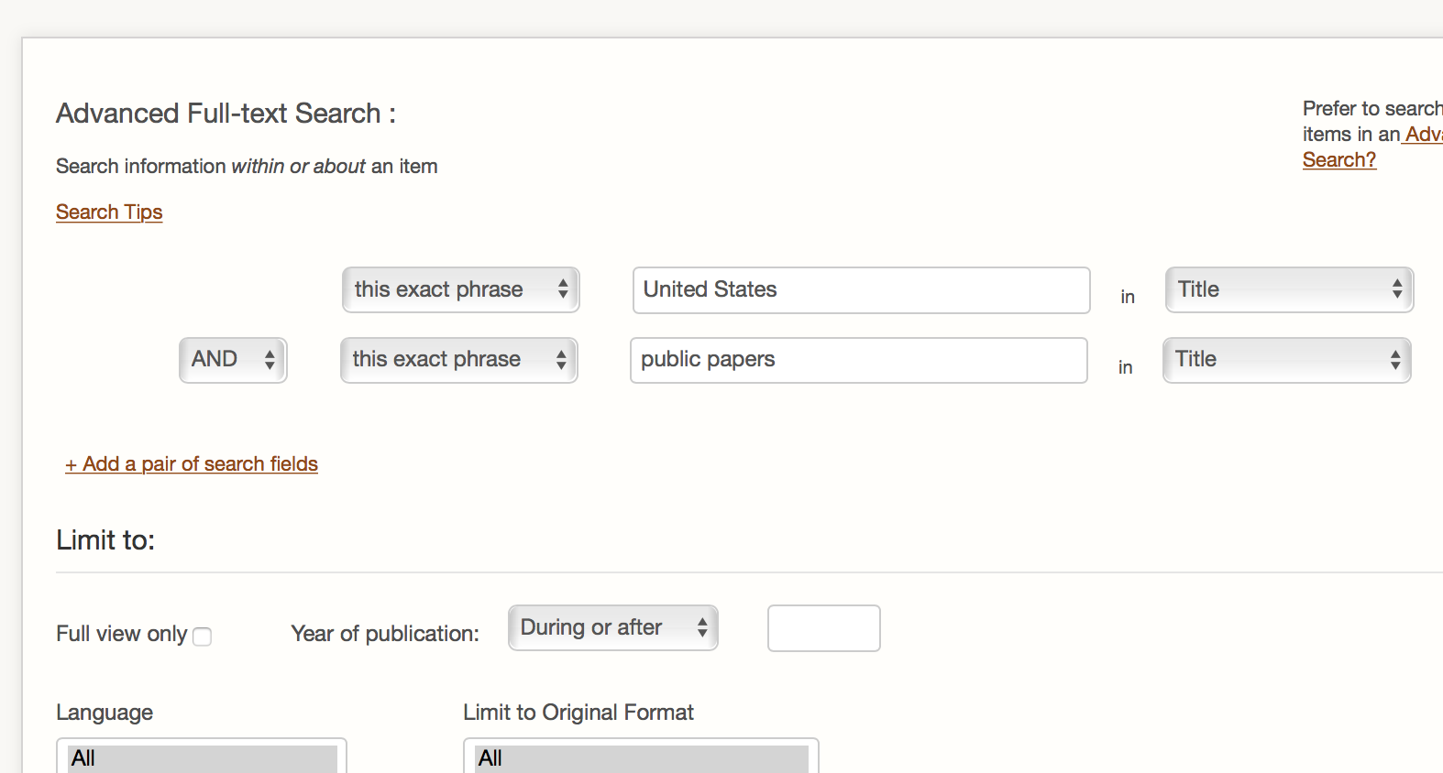
- You will see two blank search fields. Since we want to look for volumes that have two specified phrases (“public papers” and “United States”) in their titles, the “AND” logic works and we don't need to change it.
- For both search fields, select “this exact phrase” and “Title” to limit our search. Type United States in one search field and public papers in the other.
- Click “Search” at the bottom of the page.

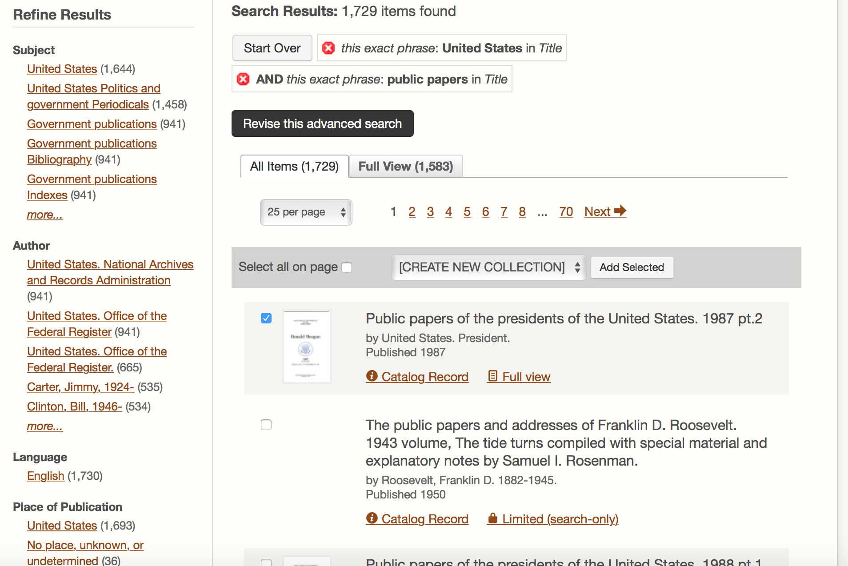
- Filter your results using the fields on the left.
- Click the checkbox next to the titles you would like to add to your collection.
- When ready to create your collection, click on the “Select Collection” bar and choose “[CREATE NEW COLLECTION]” from the drop-down menu. Click “Add Selected”.

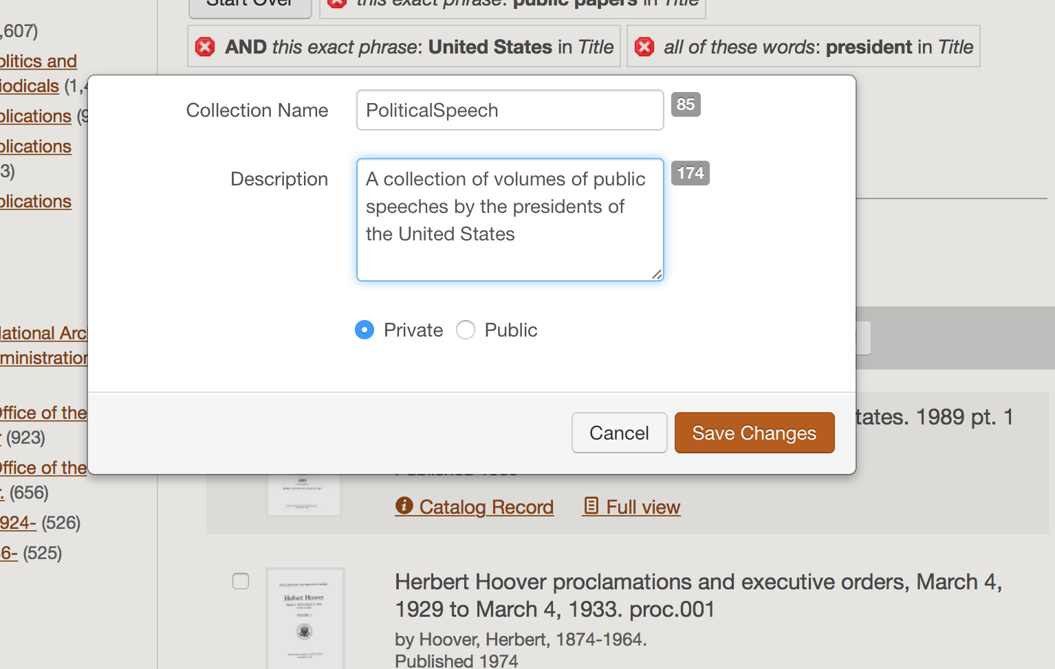
- Enter information about your collection in the pop-up window. Click “Save Changes”.
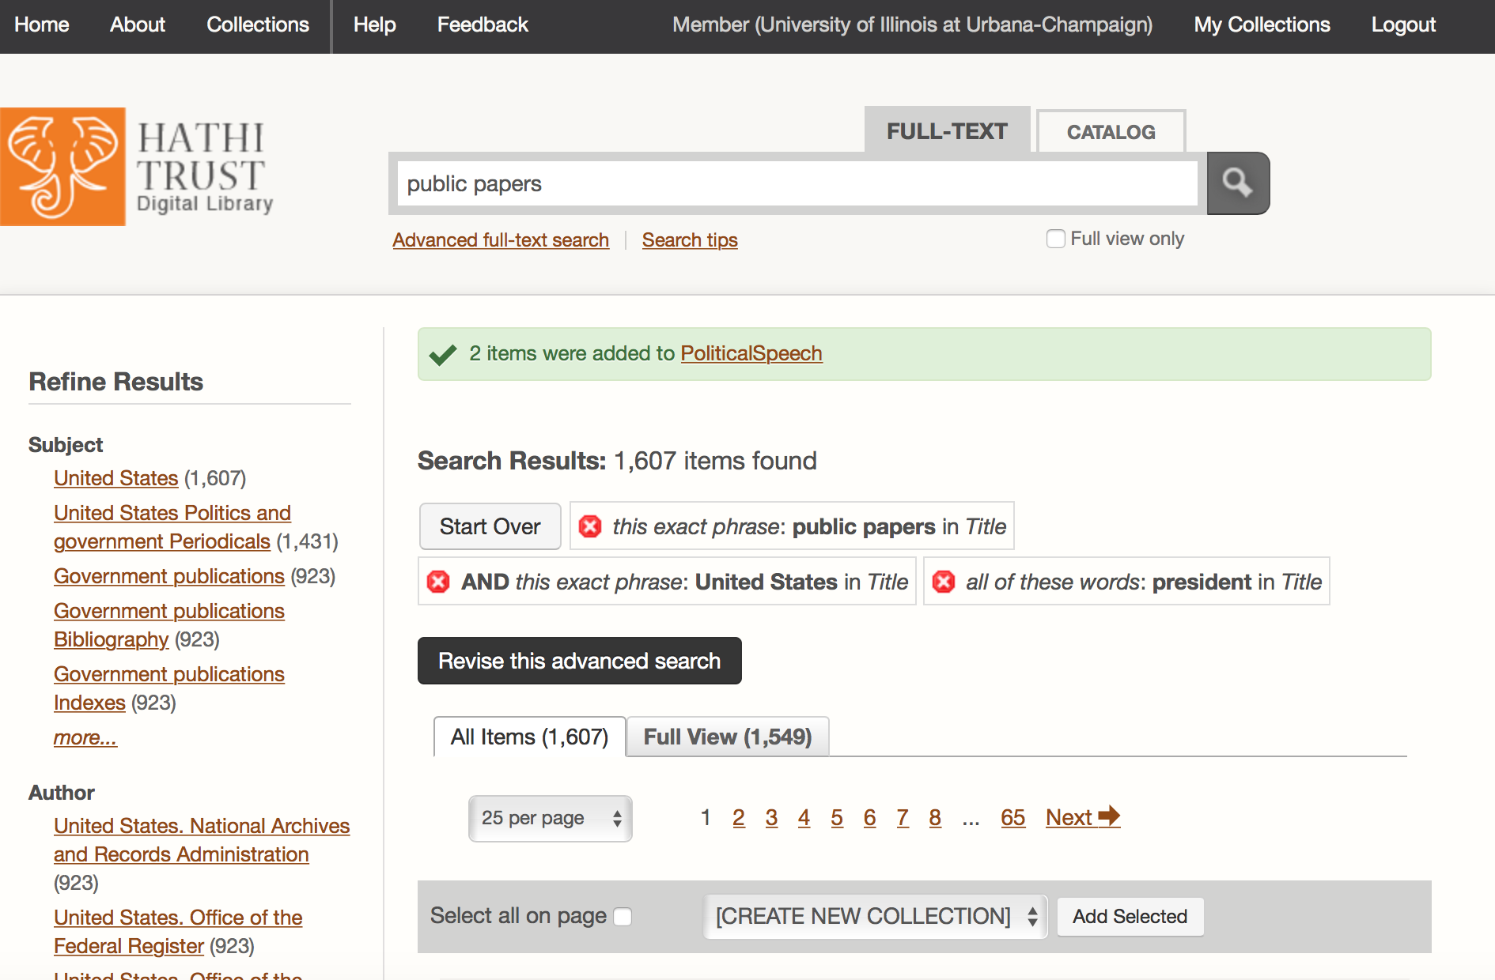
- You’ll see a confirmation that your collection was created. Click “My Collections” in the top right.

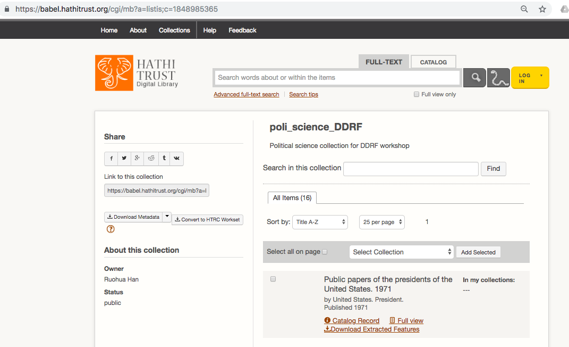
- Click the title of the collection you just created to view it.
- Copy the URL for your collection from the address bar.

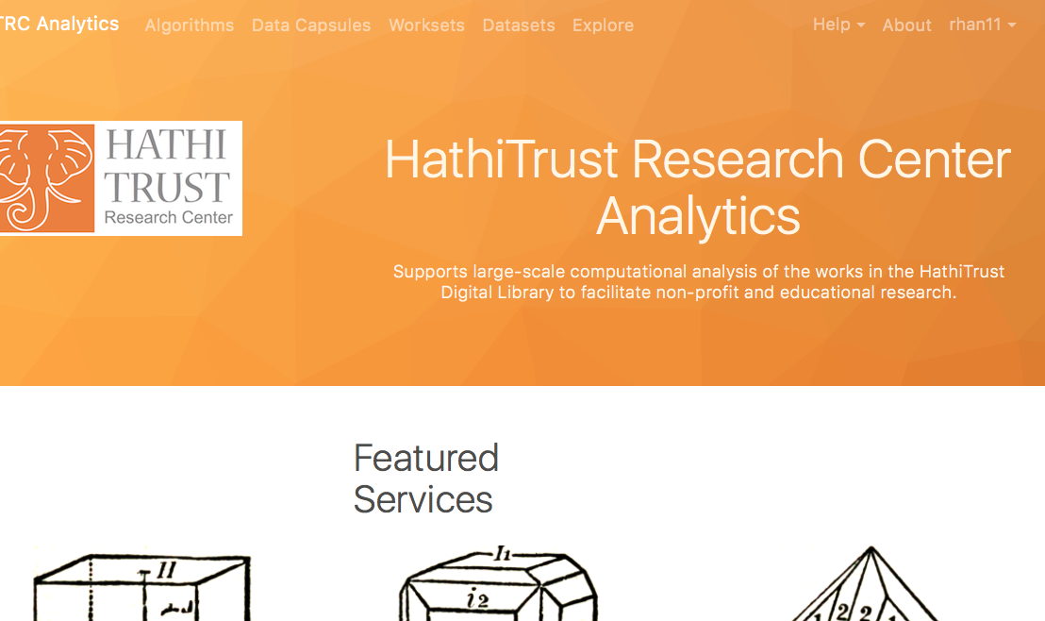
- Log in to HTRC Analytics: https://analytics.hathitrust.org

- Go to “Worksets” in the header menu.

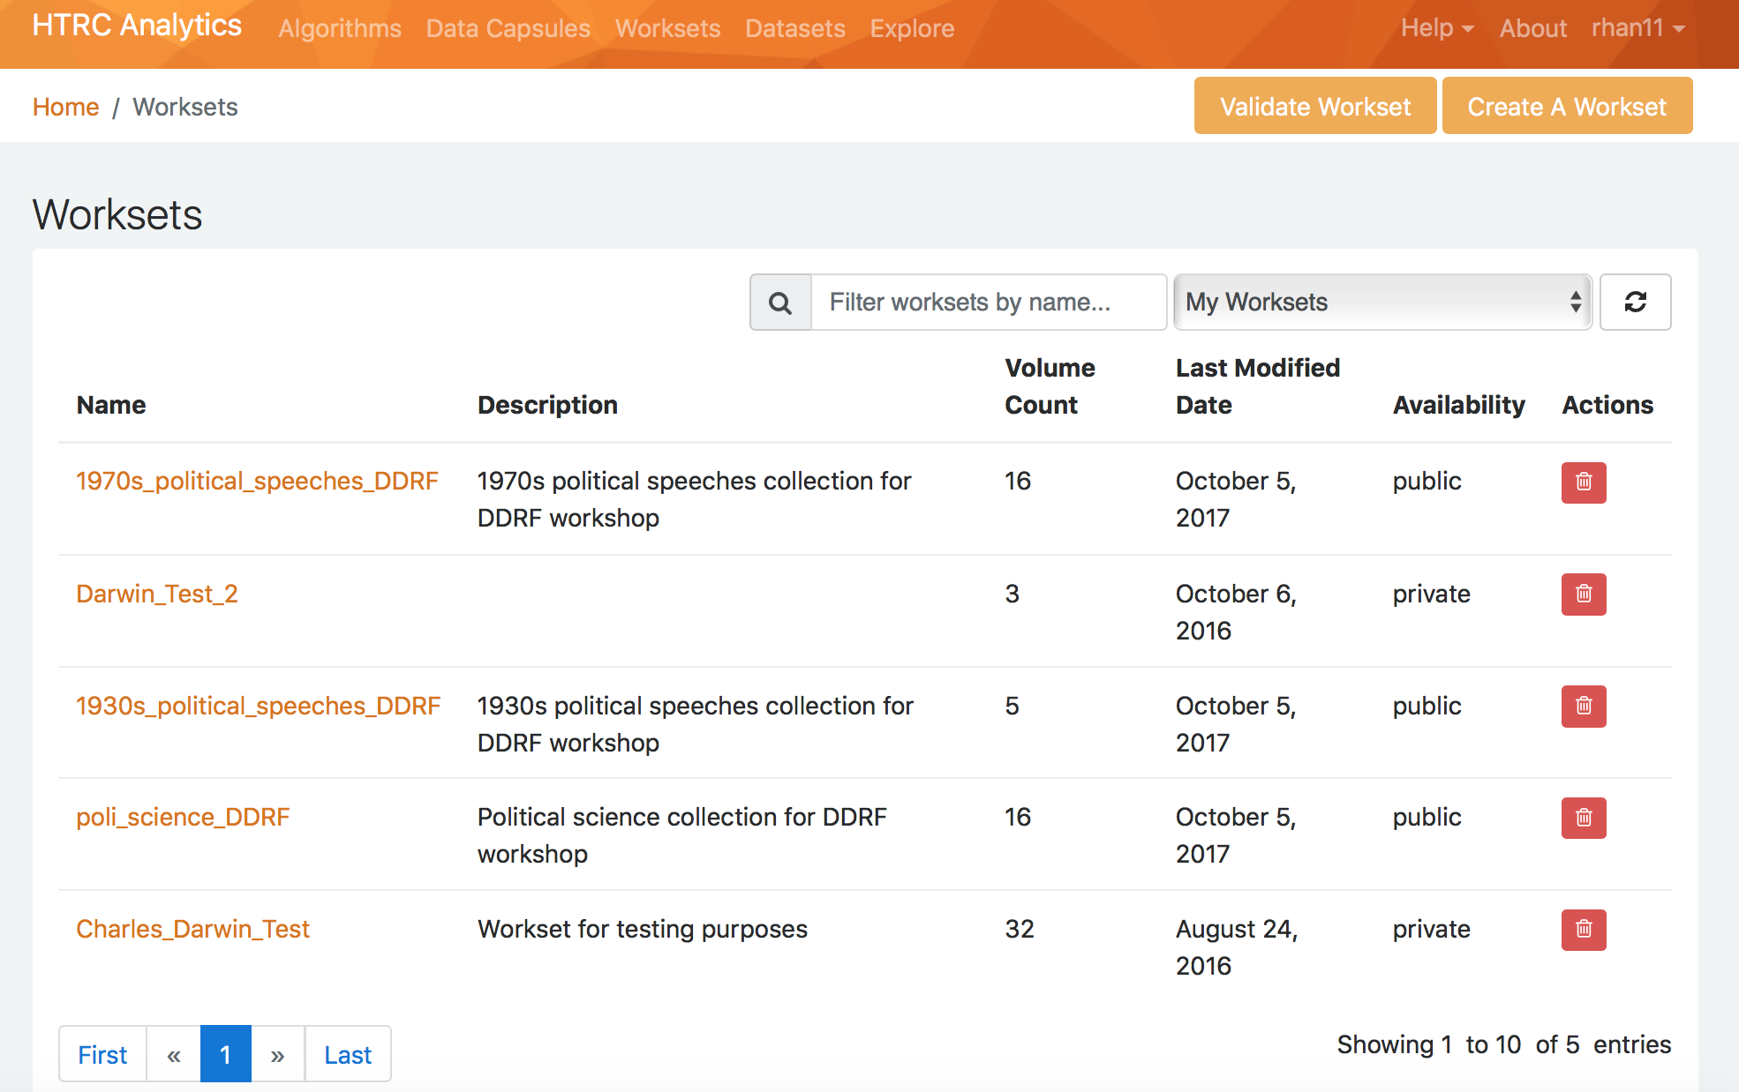
- Click on “Create a workset” near the top right.

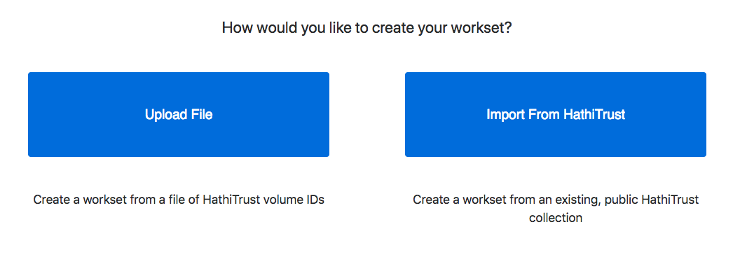
- Choose “Import from HathiTrust”

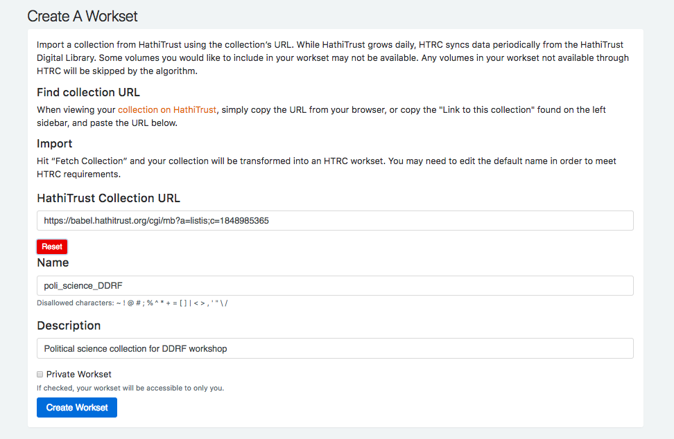

- Paste the URL for your collection in the Collection URL field and click “fetch.”
- View and/or edit the information for your workset.
- Click “Create Workset”. You should be able to find your new workset on your Worksets page.

MODULE 2.2 Gathering Textual Data: Bulk Retrieval

KEY TOOLS & PLATFORMS

PythonAnywhere
A browser-based programming environment that’s also a code editor and file hosting service. It comes with a built-in Bash shell and does not interact with your local file system.

wget
A command line tool for retrieving files from a server. It can scrape the contents of a website, with options that can be modified to tailor the parameters of the request.

ACTIVITY: Get experience with API calls Slide M2.2 – 10
Can you use the HathiTrust Bibliographic API to retrieve the metadata for a volume of your choice?
More information: https://www.hathitrust.org/bib_api
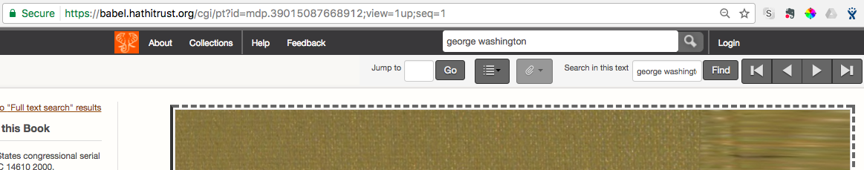
  - Search HTDL for a volume: hathitrust.org
  - Click “Full view” or “Limited (search-only)”. Which link is available depends on the volume’s rights status.

  - Look at the URL of the page and find the volume ID. It should consist of all the characters between “id=” and “;”.
  - The first characters of the identifier (i.e. pst or miua) are the code for the digitizing institution. An example of a volume ID is in bold:
https://babel.hathitrust.org/cgi/pt?id=pst.000023137875;view=1up;seq=9
- An API call generally includes a structured URL. Here’s the format for the HT Bibliographic API:
http://catalog.hathitrust.org/api/volumes
________________________________/brief OR /full
___________________________________________/<ID type>
___________________________________________________/<ID.json>
Example: https://catalog.hathitrust.org/api/volumes/full/htid/mdp.39015005337046.json
  - Type your structured URL into a new tab in your web browser and hit enter to call the metadata.

ACTIVITY: Introduction to the command line Slide M2.2 - 17
We will practice with PythonAnywhere’s built-in Bash shell. It’s useful for teaching and learning!
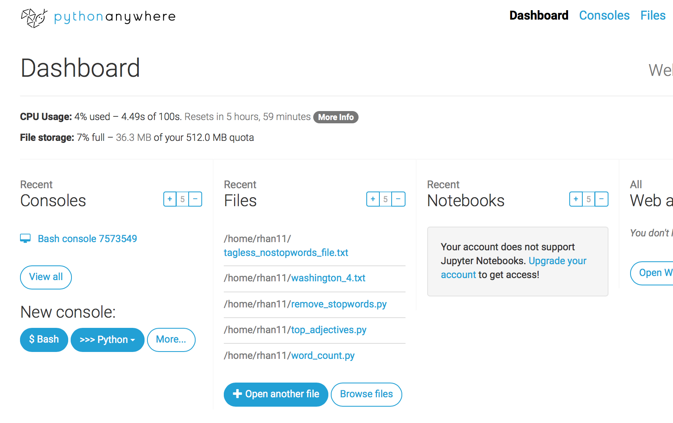
- Start a new Bash console in PythonAnywhere by going to the Dashboard and clicking on the “$ Bash” button under “New console”.
- Try basic commands to:
- See your working directory: Type and enter pwd
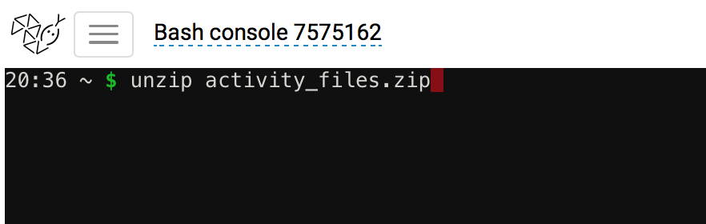
- See what is in your working directory: Type and enter ls
- Unzip and move the activity files we uploaded to PythonAnywhere at the start of the workshop.
- To unzip activity_files.zip, type and enter:
unzip activity_files.zip
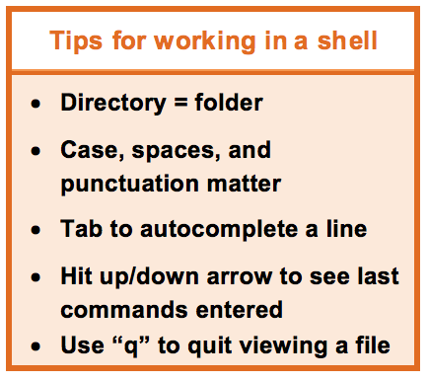
- To move the files to your user directory, type and enter:
mv activity_files/* /home/USERNAME/
Substitute your PythonAnywhere user name for USERNAME!
- Use ls to check if the files were successfully unzipped and moved.
- Practice more basic commands:
  - Make a directory called ‘test’: mkdir test
  - Change into and then back out of that directory:
cd test
cd .. NOTE: Make sure you are back in your main directory after finishing the activity.
Command | Function | Example
pwd | see which directory you’re in | pwd
mkdir | make a directory | mkdir test
cd | change directory | cd /home/your username
ls | list files and directories
mv | rename a file | mv README.txt README1.txt
less (Press “q” to quit) | view contents of a file, | less FILENAME
touch | create a new, empty file | touch file1
nano | edit a file | nano file1.txt

ACTIVITY: Web scraping with wget Slide M2.2 - 23
Practice web scraping to access a single text that may be of interest to our researcher.
- Webpage to be scraped: https://en.wikisource.org/wiki/George_Washington%27s_Fourth_State_of_the_Union_Address
- Make sure you are back in your main directory.
- In your Bash shell, type the command:
wget -l 1 --limit-rate=20k https://en.wikisource.org/wiki/George_Washington%27s _Fourth_State_of_the_Union_Address --output-document=washington_4.txt

NOTE: Ensure the apostrophe has been “escaped” using the code %27s as seen above.
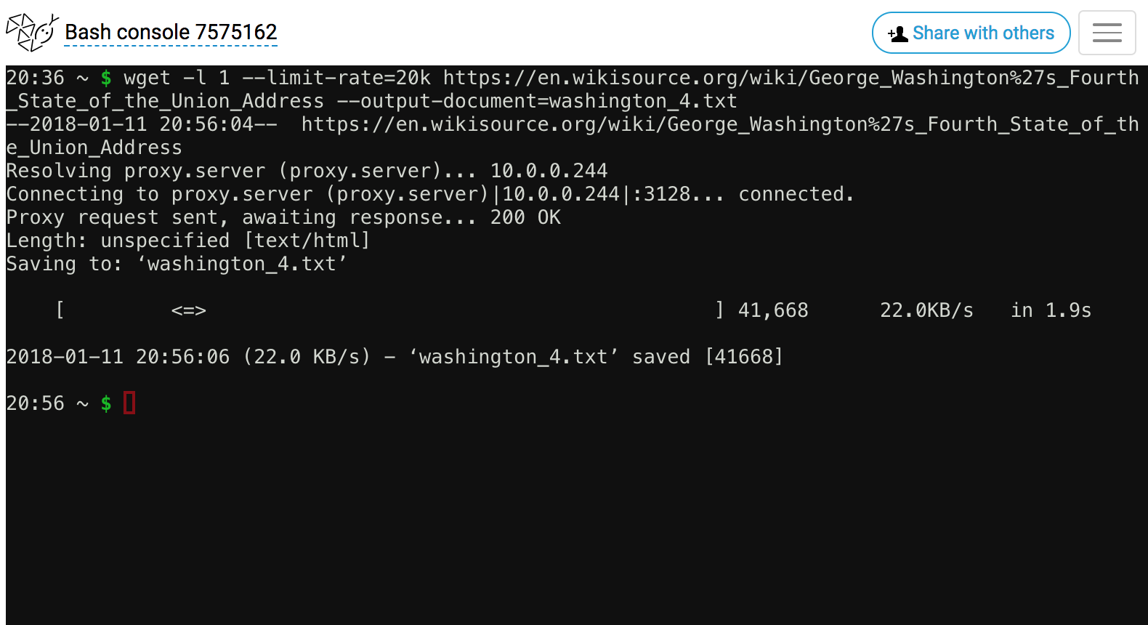
- Click the “PythonAnywhere” logo in the top left corner to go back to the Dashboard.

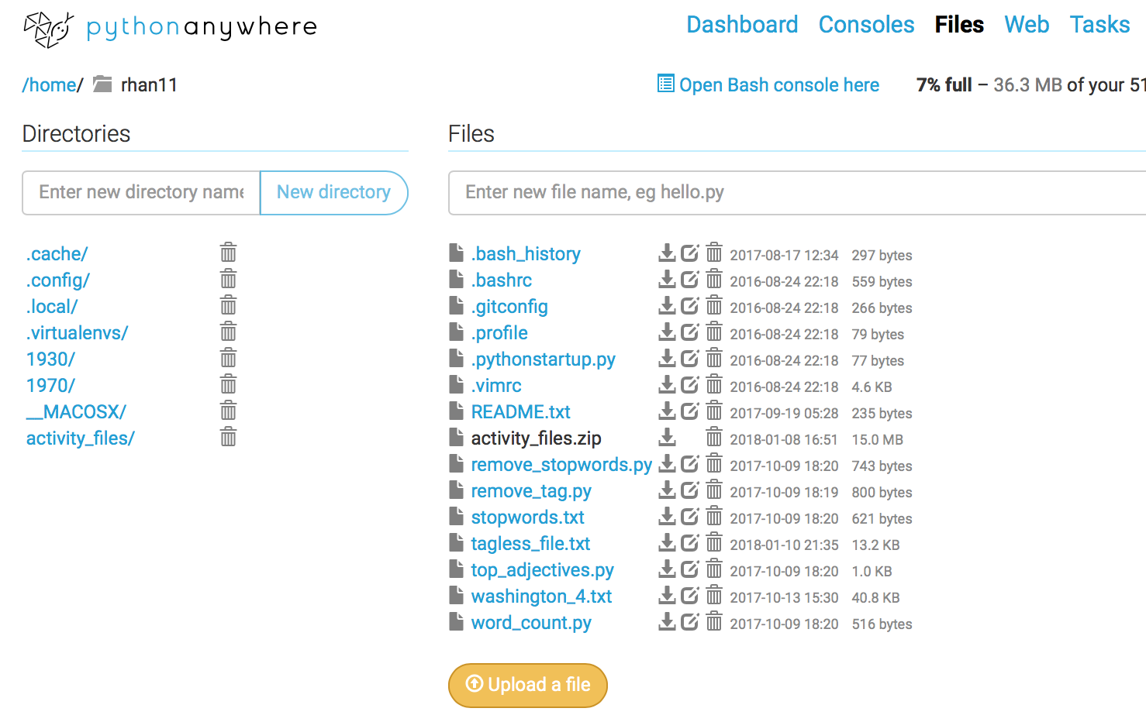
- Click on the “Browse files” button in the Files column, or click on the “Files” option in the upper right corner of the page.

- Note your new washington_4.txt file in your list of files. This was the one just generated.

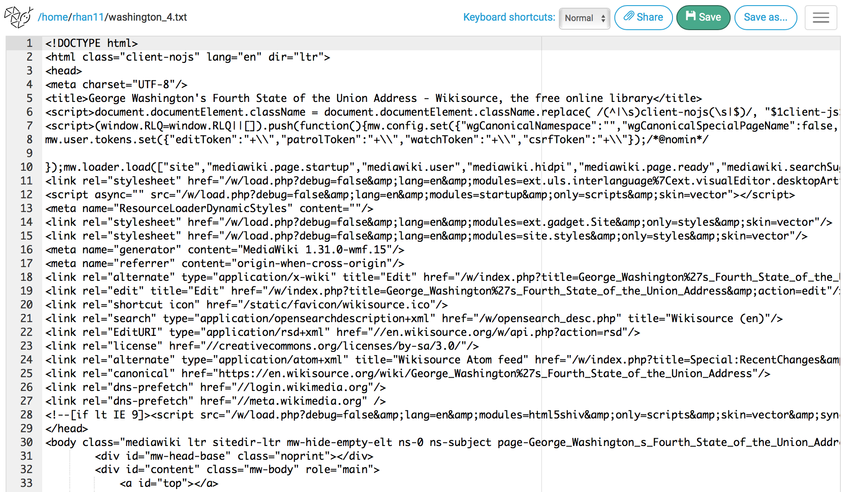
- Click on the file name to view the file contents.

- Notice that all the html tags are still included.

- You could also view the file using the command less washington_4.txt in your console. (Press “q” to quit viewing when you finish.)

ACTIVITY: More web scraping with wget Slide M2.2 - 31
- Now you try! Can you modify the command to scrape George Washington’s second State of the Union Speech?
wget -l 1 --limit-rate=20k https://en.wikisource.org/wiki/George_Washington%27s_Second_State_of_the_Union_Address --output-document=washington_2.txt

- Can you view your scraped files using the less command?
less washington_2.txt

READ AND REFLECT: Collections as Data Slide M2.2 - 36
Santa Barbara Statement on Collections as Data (Collections as Data National Forum, 2017) https://collectionsasdata.github.io/statement/
Select points from the Statement:
- With a few exceptions, cultural heritage institutions have rarely built digital collections or designed access with the aim to support computational use. Thinking about collections as data signals an intention to change that.
- While the specifics of how to develop and provide access to collections as data will vary, any digital material can potentially be made available as data that are amenable to computational use. Use and reuse is encouraged by openly licensed data in non-proprietary formats made accessible via a range of access mechanisms that are designed to meet specific community needs.
- Ethical concerns are integral to collections as data.
- Principle 2 for collections as data: “Collections as data development aims to encourage computational use of digitized and born digital collections.”

Discussion questions:
- Does your library provide access to digital collections as data?
- How so? Why not? How could it?

MODULE 3 Working with Textual Data
KEY TOOLS
Python
A programming language that is commonly used when working with data. Python has high-level data structures, is interpretive in nature, and has a relatively simply syntax.

ACTIVITY: Teach your neighbor about text pre-processing Slide M3 - 11
Term | Definition
Punctuation | “The first choice a researcher must make when deciding how to preprocess  a corpus is what classes of characters and markup to consider as valid text. The most inclusive approach is simply to choose to preprocess all text, including numbers, any markup (html) or tags, punctuation, special characters ($, %, &, etc), and extra white-space characters. These non-letter characters and markup may be important in some analyses (e.g. hashtags that occur in Twitter data), but are considered uninformative in many applications. It is therefore standard practice to remove them. The most common of these character classes to remove is punctuation.”
Numbers | “While punctuation is often considered uninformative, there are certain  domains where numbers may carry important information. For example, references to particular sections in the U.S. Code (‘Section 423’, etc.) in a corpus of Congressional bills may be substantively meaningful regarding the content legislation. However, there are other applications where the inclusion of numbers may be less informative.”
Lowercasing | “Another preprocessing step taken in most applications is the lowercasing  of all letters in all words. The rationale for doing so is that that whether or  not the first letter of a word is uppercase (such as when that words starts a sentence) most often does not affect its meaning. For example, ‘Elephant’ and ‘elephant’ both refer to the same creature, so it would seem odd to count them as two separate word types for the sake of corpus analysis. However, there are some instances where a word with the same spelling may have two different meanings that are distinguished via capitalization, such as ‘rose’ (the flower), and ‘Rose’ the proper name.”
Stemming | “The next choice a researcher is faced with in a standard text preprocessing  pipeline is whether or not to stem words. Stemming refers to the process of  reducing a word to its most basic form (Porter, 1980). For example the words ‘party’, ‘partying’, and ‘parties’ all share a common stem ‘parti’. Stemming is often employed as a vocabulary reduction technique, as it combines different forms of a word together. However, stemming can sometimes combine together words with substantively different meanings (‘college students partying’, and ‘political parties’), which might be misleading in practice.”
Stopword Removal | “…some words, often referred to as “stop words”, are unlikely to convey much information. These consist of function words such as ‘the’, ‘it’, ‘and’, and ‘she’, and may also include some domain-specific examples such as ‘congress’ in a corpus of U.S. legislative texts. There is no single gold-standard list of English stopwords, but most lists range between 100 and 1,000 terms.”
n-gram Inclusion | “While it is most common to treat individual words as the unit of analysis, some words have a highly ambiguous meaning when taken out of context. For example the word ‘national’ has substantially different interpretations when used in the multi-word expressions: “national defense”, and “national debt”. This has led to a common practice of including n-grams from documents where an n-gram is a contiguous sequence of tokens of length n (Manning and Schutze, 1999). For example, the multi-word expression ‘a common practice’ from the previous sentence would be referred to as a 3-gram or tri-gram.”
Infrequently Used Terms | “In addition to removing common stopwords, researchers often remove terms that appear very infrequently as part of corpus preprocessing. The rationale for this choice is often two-fold; (1) theoretically, if the researcher is interested in patterns of term usage across documents, very infrequently used terms will not contribute much information about document similarity. And (2) practically, this choice to discard infrequently used terms may greatly reduce the size of the vocabulary, which can dramatically speed up many corpus analysis tasks.”
From: https://papers.ssrn.com/sol3/papers.cfm?abstract_id=2849145 (Denny and Spirling, 2017)
ACTIVITY: Run a Python script to strip HTML tags from a text file Slide M3 - 17
In order to make our Washington speech file more useful, we’ll need to remove the HTML tags.

- In your Bash shell type the command: python remove_tag.py washington_4.txt
- Go back to the Dashboard by clicking on the “PythonAnywhere” logo in the top left corner.
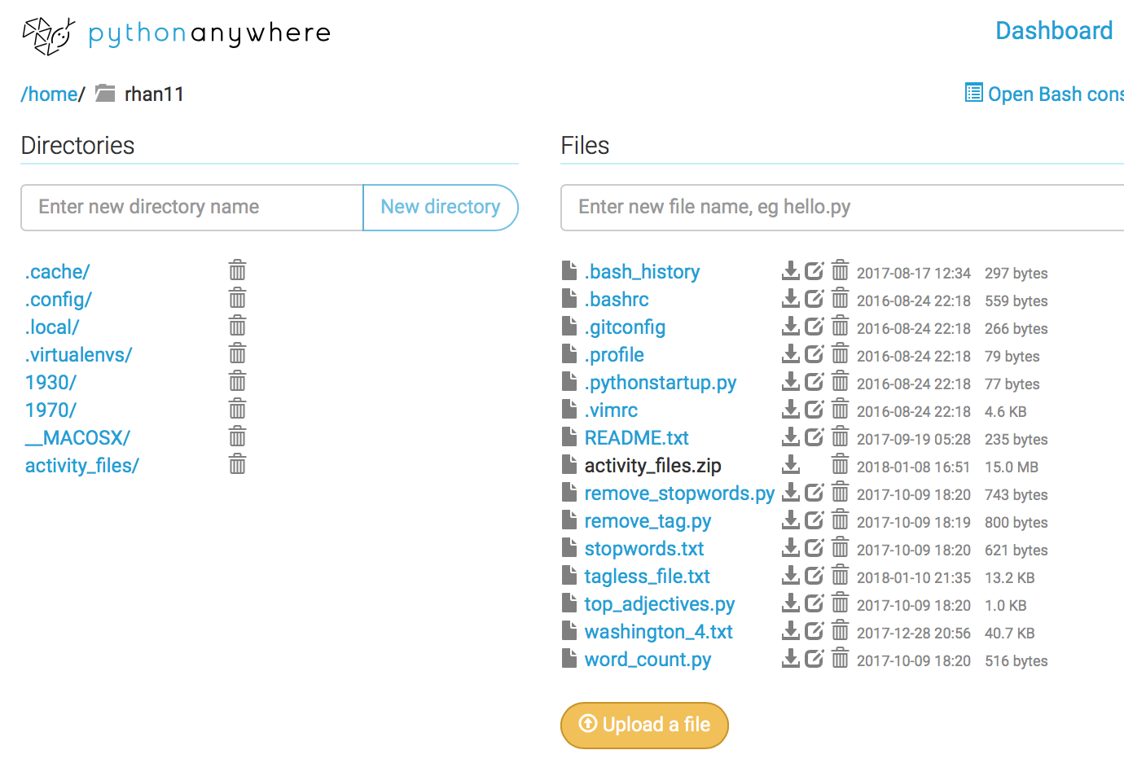
- Click on the “Browse files” button in the Files column Or click on the “Files” option in the upper right corner of the page.

- In your list of files, you should now see a file named “tagless_file.txt”. Click on it to preview your results. If it is too difficult to read the unwrapped text here, you can go to your Bash console and use “less tagless_file.txt” to view the file content in your console instead. Press “q” to quit viewing.
- The “tagless_file.txt” file should contain a clean version of your web scraped text.

ACTIVITY: Now you try! Slide M3 - 25
- Can you run the script [remove_stopwords.py] to remove the stopwords?
  - Hint: the remove_tag.py script we just ran required only a single argument, which was for the file to remove the tags from (washington_4.txt). The remove_stopwords.py script requires three arguments in addition to the name of the script you want to execute:
    - The input file (your tagless file)
    - The list of stop words (stopwords.txt)
    - The output file name (you make this up!)
  - Remember to put a space between each argument.

python remove_stopwords.py tagless_file.txt stopwords.txt washington_4_stops_removed.txt
- Can you edit the stopwords.txt file to customize your list? Are there any stop words you think would be important to remove from this text? Yes. Edit stopwords.txt file.

Read and Reflect: Humanities Data Slide M3 - 27

Katie Rawson and Trevor Muñoz, “Against Cleaning”
http://curatingmenus.org/articles/against-cleaning/
‘When humanities scholars recoil at data-driven research, they are often responding to the reductiveness inherent in this form of scholarship. This reductiveness can feel intellectually impoverishing to scholars who have spent their careers working through particular kinds of historical and cultural complexity… From within this worldview, data cleaning is then maligned because it is understood as a step that inscribes a normative order by wiping away what is different. The term “cleaning” implies that a data set is “messy.” “Messy” suggests an underlying order. It supposes things already have a rightful place, but they’re not in it—like socks on the bedroom floor rather than in the wardrobe or the laundry hamper.’

Discussion Questions:
- What does this piece suggest about the nuances of data cleaning?
This may not always be the best choice. Cleaning the data can change the meanings. By removing punctuation, for example, makes meanings unclear (questions vs. statements). There are ethical issues involved with changing raw data. Depending on the nature of the original data, cleaning it could take away the original meaning or effectively silence some perspectives.
- What does “clean” imply?
That working with the original data is bad.
- How might you talk to researchers on your campus who would be uncomfortable with the idea of clean vs. messy data?

MODULE 4.1 Performing Text Analysis: Using Off-the-Shelf Tools

KEY TOOLS

HTRC algorithms
A set of off-the-shelf text analysis algorithms provided via HTRC Analytics for users to analyze their worksets, such as algorithms for extracting named entities and doing topic modeling.

ACTIVITY: Review algorithm descriptions Slide M4.1 – 13
Link to algorithm descriptions: https://wiki.htrc.illinois.edu/x/HoJnAQ
In pairs or small groups, please read the descriptions for the following the HTRC algorithms. Can you explain to one another what each of them does? What kind of research questions might they help answer?

Tool | What does it do? | Example research question?
Token Count and Tag Cloud Creator | Creates a tag cloud of the most frequently occurring words. | Identify themes.
Named Entity Recognizer | Generates a list of people, places, dates, times, percentages, monetary terms. | Determine geographic extent of a text. Genealogy, social network overlap.
InPhO Topic Model Explorer | Generates "topics" based on words that have a high probability of occurring close together in the text. | Identify topics in discussions on social media

ACTIVITY: Running an algorithm in HTRC Analytics Slide M4.1 - 15
Let’s try performing a popular text analysis method, topic modeling, using a web-based tool.
- From the homepage of HTRC Analytics, click “Algorithms.”

- Click on the “Execute” button under the name and description of the algorithm you want to run. Select “InPhO Topic Model Explorer (v1.0)” for this activity.

- Choose a workset from either all worksets or just your private worksets.
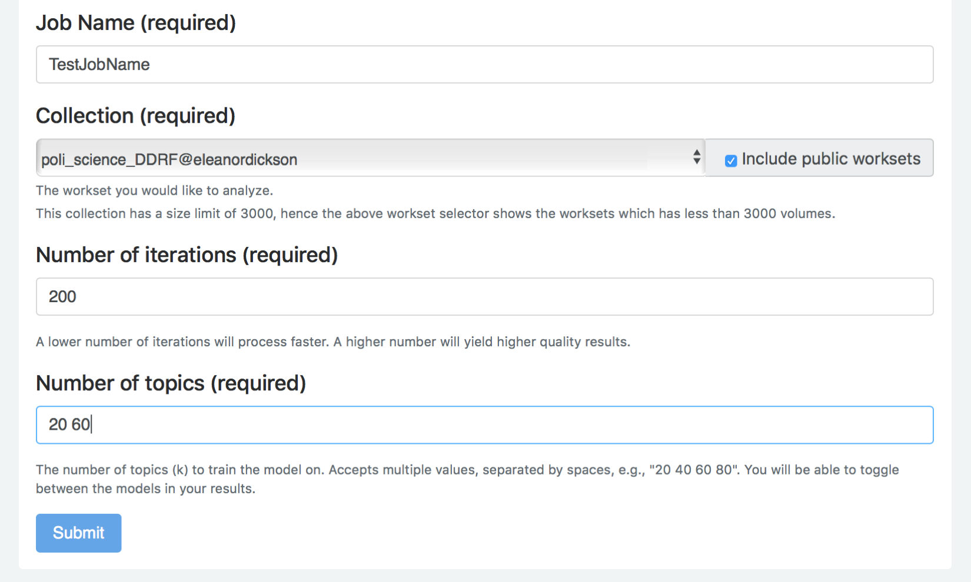
- For this example exercise, check the “Include public worksets” option and select “poli_science_DDRF@eleanordickson”.
- To navigate to the workset more quickly, after clicking on the arrow button to expand the list of worksets, type “EF” and the down arrow and the workset that we need will appear at the bottom of the list.
- Enter a name for your job, type “200” for the number of iterations, and type “20 60” for the number
of topics to be created. Click “Submit.”

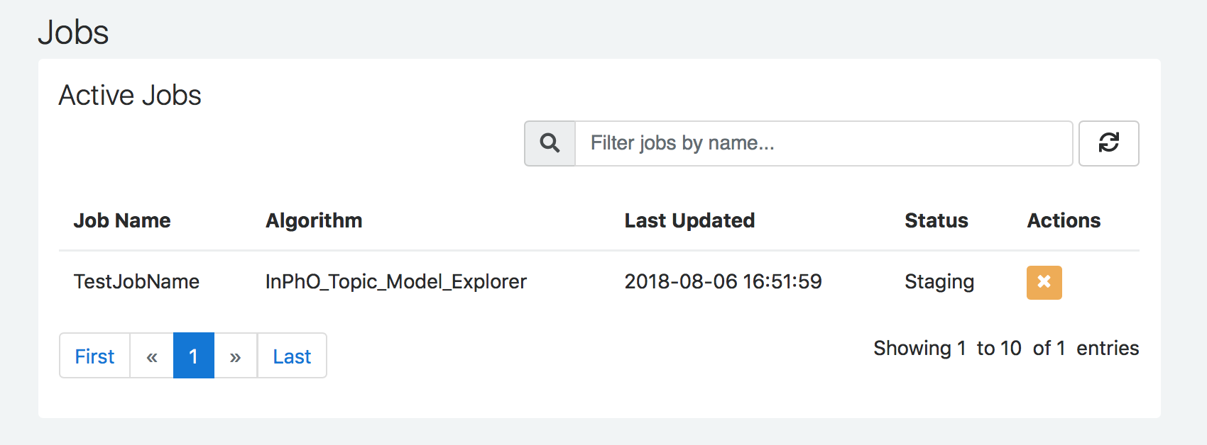
- See the current job in “Active Jobs” and refresh your screen to see the status change.
- You may have to be patient while it finishes, especially if the workset is large.
- Once the job is done, it will be listed under “Completed Jobs.”
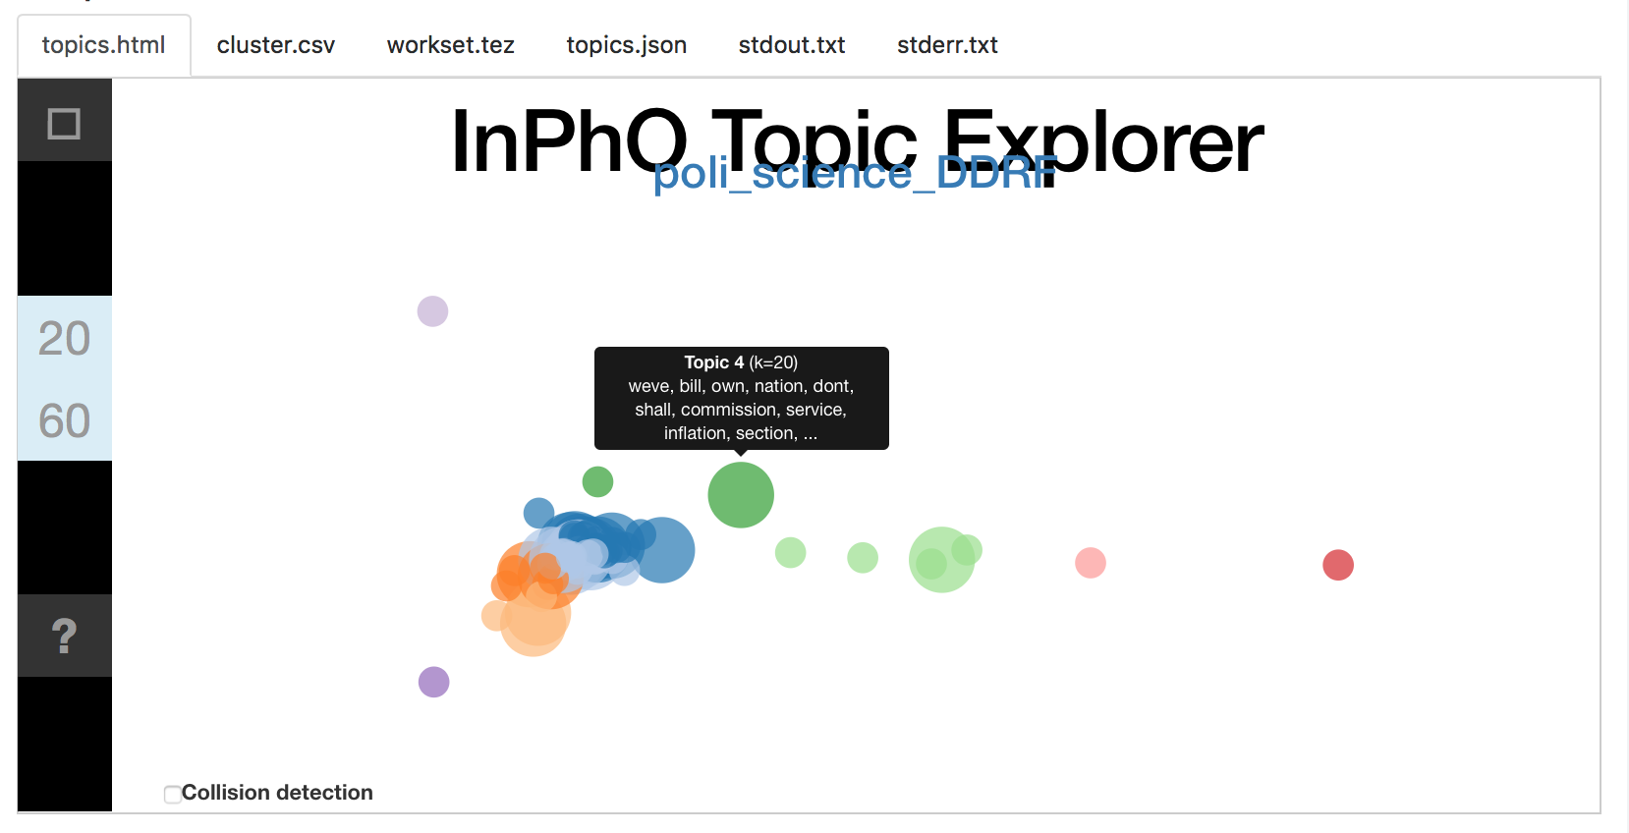

- Click on the job name to see the results. Scroll to the “output” area to see the bubble visualization of the generated topics. Hover over a bubble to see the top terms in a topic.

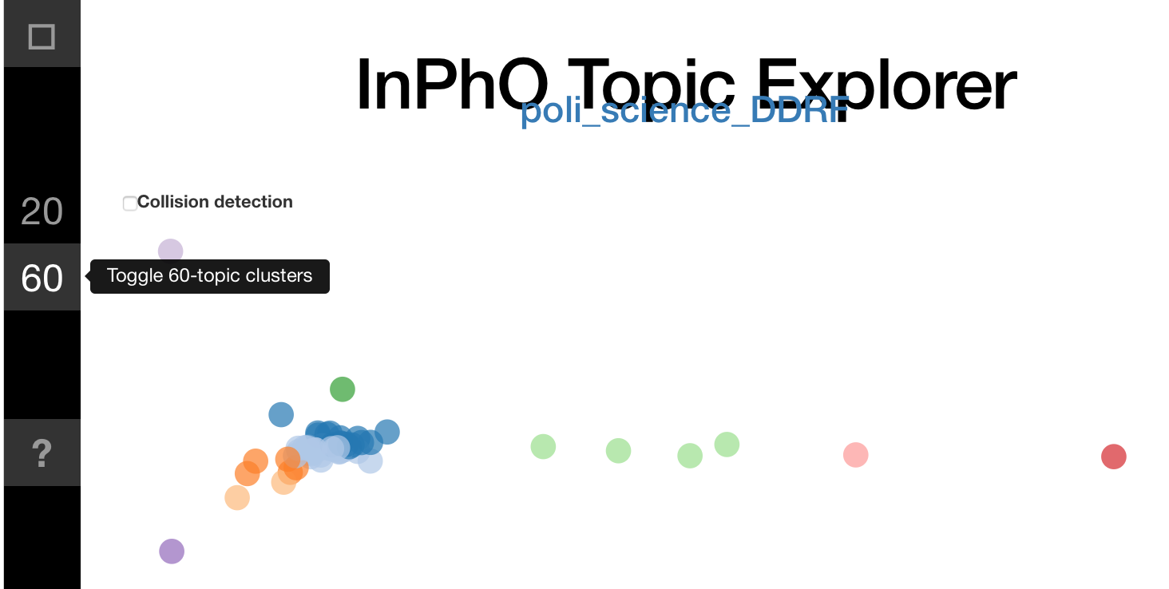
- The numbers on the side relate to the number of topics generated, as do the size of the bubbles. Toggle the display of the n-topic clusters by clicking on those numbers.

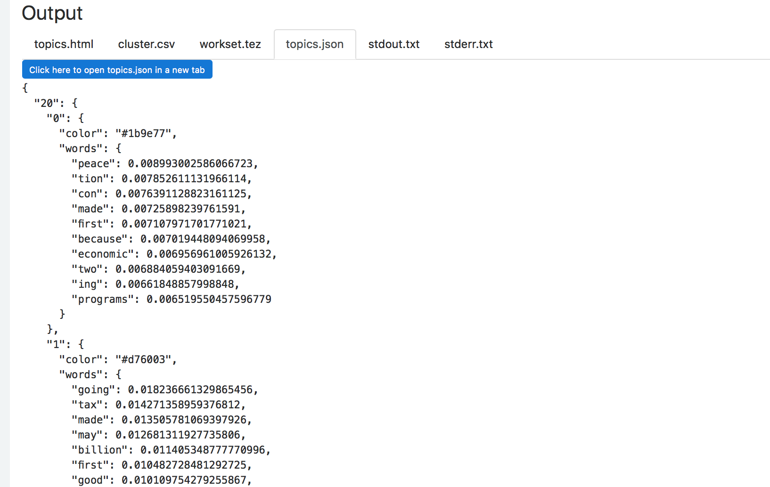
- You can also view and download 3 results files: topics.json, cluster.csv, and workset.tez. These files can be used to play with the visualization in more depth outside HTRC Analytics.

MODULE 4.2 Performing Text Analysis: Basic Approaches with Python
KEY TOOLS/PLATFORMS

Python
A programming language that is good for working with data.

pip
A package manager for Python

pyplot
Visualization function in the Python data science package, Pandas
HTRC Extracted Features
A downloadable dataset of text data and metadata extracted and abstracted from volumes in the HathiTrust Digital Library.

HTRC Feature Reader
A Python library for working with HTRC Extracted Features.

ACTIVITY: Identify the method Slide M4.2 - 6
What are the broad areas and methods used for the research examples we read earlier?
Project summaries: http://go.illinois.edu/ddrf-research-examples
 | Broad area | Specific method
Rowling and “Galbraith”: an authorial analysis | Natural Language Processing | Stylometry
Significant Themes in 19th Century Literature | Machine Learning | Topic modeling
The Emergence of Literary Diction | Machine Learning | Naive Bayes Classification

ACTIVITY: View adjectives in Extracted Features files Slide M4.2 - 26
- Go to your PythonAnywhere dashboard and click on the “Browse files” button to check if all files and directories are in place
- On your “Files” page, you will see your directories on the left and your files on the right.
- You should have two directories “1930/” and “1970/” listed on the left.
- Click on each directory.
- There should be 16 json.bz2 files in the “1970/” directory that correspond to the volumes in the poli_science_DDRF workset atn 5 json.bz2 files in the “1930/” directory of Presidential Papers volumes from the 1930s.
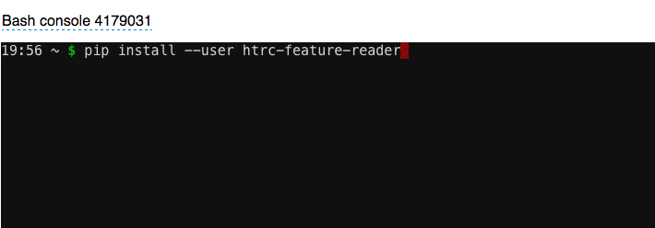
- Open the Bash console.
- Install the Feature Reader Library by typing:
pip install --user htrc-feature-reader
- Hit enter.
- From the Bash shell, run the script. Enter command (remember to use the tab key to help you automatically complete the file names):
python top_adjectives.py 1970
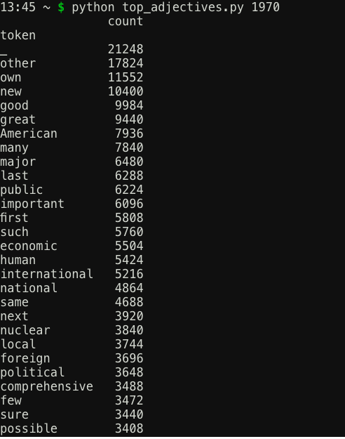
- Hit Enter. The results will be printed out directly in the window.

ACTIVITY: Now you try! Slide M4.2 - 32
- Compare the adjectives used by presidents in the 1970s with those used in the 1930s.
- Work and discuss with your neighbor.
  - How do you need to change your command? python top_adjectives.py 1930
  - What differences do you see? Similarities? 1930s: industrial 1970s: nuclear, international much higher on the list
Challenge | Try modifying the script to search verbs or another part of speech.  (Hint: Don’t forget the Penn Tree Bank – you can find it here: https://www.ling.upenn.edu/courses/Fall_2003/ling001/penn_treebank_pos.html )

Open the file, and replace JJ with another code from the Penn Tree Bank, such as VB for verb.
ACTIVITY: Visualize word trends Slide M4.2 - 36
- Open the Bash console
- Enter the command “python word_count.py”
- Click the “PythonAnywhere” logo to go back to the home screen and go to your Files.

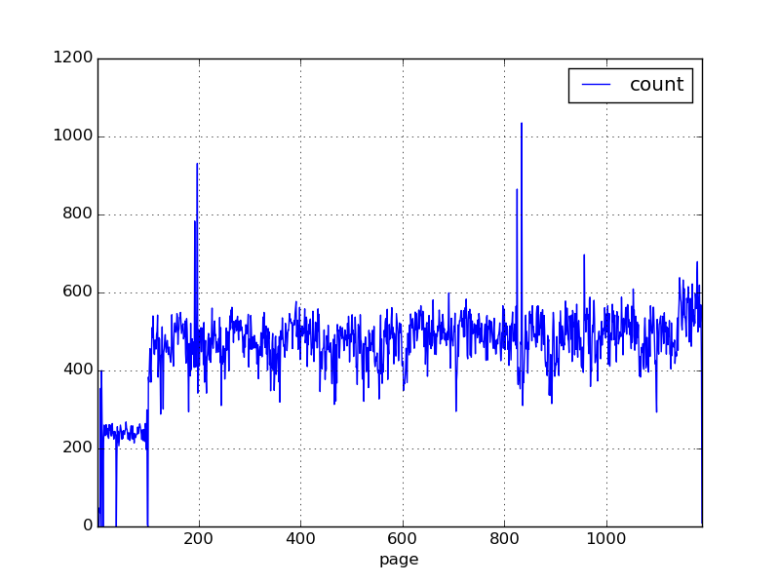
- The “words.png” file should be in your Files. Click on the download icon to the right of the file name to open the file.

ACTIVITY: Now you try! Slide M4.2 - 40
- Can you modify the script to look at another volume?
In line 10 on the script, change the path to another volume:
Example 1: path = glob.glob('1970/ mdp.49015002221761.json.bz2')
Example 2: path =glob.glob('1930/miua.4925052,1928,001.json.bz2')
MODULE 5 Visualizing Textual Data: An Introduction

KEY TOOLS/PLATFORMS

HathiTrust + Bookworm
A tool that visualizes word frequencies over time in the HathiTrust Digital Library. It can be accessed at: https://bookworm.htrc.illinois.edu/develop.

ACTIVITY: Which visualization technique? Slide M5 – 14
Match the type of use to type of visualization:
Visualization | What would it be good for? |  | Uses
Word cloud | Topical density |  | Change over time  Spatial  Topical density  Relationships  Word distribution
Trees or hierarchies | Word distribution
Networks | Relationships
Timeline | Change over time
Map | Spatial
Bubble chart | Change over time
Heat map | Topical density
Bonus: what kinds of variables (i.e. data points) you would need for each visualization?

ACTIVITY: Visualize word trends Slide M5 - 26
Use the HT+BW tool at: https://bookworm.htrc.illinois.edu/develop to visualize political concepts
- As examples, you could try: fascism, socialism, nationalism, or internationalism.
- Experiment with the settings and faceting.
- Get creative

GLOSSARY OF KEY TERMS

Algorithm: A process a computer follows to solve a problem, creating an output from a provided input.
Bag-of-words model: A concept for working with text where all grammar and word order has been taken out and all the words are like being mixed up in a bag.
Chunking text: The process of splitting text into smaller pieces before analysis. May be divided by paragraph, chapter, or a chosen number of words.
Data visualization: The process of converting data sources into a visual representation. It often also refers to the product of this process.
Distant reading: An approach that takes large amounts of literature and “reads” them with computational analysis, thus “reading” them at a “distance.” (Concept by Franco Moretti)
Exploratory data analysis: an approach for familiarizing oneself with a dataset before analyzing it that often involves visualizing the dataset to get a feel for its contents.
Functions: Reusable code blocks that perform an action.
Grouping text: The process of combining text into larger pieces before analysis.
Humanities data: In a humanities research setting, “data” can be defined as material generated or collected while conducting research. Humanities data may include databases, citations, software code, algorithms, documents, etc. (Adapted from definition provided in Data Management Plans for NEH Office of Digital Humanities Proposals and Awards)
Job (in HTRC context): An algorithm run against a workset in HTRC Analytics.
Libraries/packages: Collections of functions that can be implemented in a script or program.
Machine Learning: A process that gives computers the ability to learn without being explicitly programmed. Machine learning is based on researchers constructing and using algorithms that can learn from and make predictions on data. It can either be unsupervised (with minimal human intervention) or supervised (with more human intervention).
Topic modeling – A method of using statistical models for discovering the abstract "topics" that occur in a collection of documents.
Naïve Bayes classification – A method based on Bayes’ Theorem from statistics that uses machine learning to classify texts based on information present in the texts of each class.
Natural Language Processing (NLP): Using computers to understand the meaning, relationships, and semantics within human-language text.
Named entity extraction: Using computers to locate and classify named entities (such as the names of persons, organizations, and locations) in text.
Sentiment analysis: Using computers to systematically identify attitudes or emotions present in text.
Stylometry: The application of the study of linguistic style. It is often used to determine authorship to anonymous or disputed texts.
N-grams: A contiguous chain of n items from a sequence of text where n is the number of items. Unigrams refer to one item chains, bigrams to two item chains, and so on.
Node-link diagram: A type of visualization for displaying networks. It captures entities (such as people, places, and topics) as nodes (also called “vertices”) and relationships as links (also called “edges”), with a circle or dot representing a node, and a line representing a link.
Non-consumptive research: Research in which computational analysis is performed on text, but not research in which a researcher reads or displays substantial portions of the text to understand the expressive content presented within it.
Optical character recognition (OCR): Mechanical or electronic conversion of images of typed, handwritten or printed text into machine-encoded text. The quality of the results of OCR can vary greatly, and raw, uncorrected OCR is referred to as "dirty" because it often contains mistakes, while corrected OCR is referred to as “clean”.
Package Manager: A tool that facilitates the download and installation of programming packages.
Results (in HTRC context): The results of your job(s) outputted by the algorithm. Can be downloaded.
Script: A file containing a set of programming statements that can be run using the command line. Python scripts are saved as files ending with the extension “.py”.
Stop words: Frequently used words (like “the”, “and”, “if”) that are often removed from text before analysis.
Text analysis: Computer-aided methods for discovering patterns in textual data.
Text corpus/corpora: A “corpus” of text can refer to both a digital collection and an individual's research text dataset. Text corpora, the plural form, are bodies of textual data.
Timeline: A graphic design displaying events in chronological order.
Tokenization: Breaking text into pieces called tokens. Often certain characters, such as punctuation marks, are discarded in the process.
Topic modeling: A method of using statistical models for discovering the abstract "topics" that occur in a collection of documents.
Web scraping: The process of extracting data from webpages.
Word cloud/tag: A graphical representation of word frequency, usually presenting words that appear more frequently in the source text larger than those that appear less frequently.
Word tree: A type of visualization that displays the different contexts in which a word or phrase appears in a text, with the contexts arranged in a tree-like structure to reveal recurrent themes and phrases.
Workset (in HTRC environment): A collection of HathiTrust content created by users with some additional metadata about the collection.
Volume: In the HathiTrust Digital Library, generally a digitized book, periodical, or government document.
GLOSSARY OF TEXT ANALYSIS TOOLS
AntConc: A freeware corpus analysis toolkit for text analysis, especially for analyzing concordances. See more at: http://www.laurenceanthony.net/software/antconc/
API (Application Programming Interface): A set of clearly-defined communication methods (may include commands, functions, protocols, objects, etc.) that can be used to interact with an external system. APIs basically are instructions (written in code) for accessing systems or collections.
ArcGIS Online/StoryMaps: A visualization tool that can be used to incorporate GIS information and maps into interactive timelines and stories.
https://storymaps.arcgis.com/en/
Beautiful Soup: A Python-based web scraping tool that pulls data out of HTML and XML files. It has several options for specifying what you want to scrape (within the HTML) and is good for getting clean, well-structured text.
Command line: A text-based interface that takes in commands and passes them to the computer's operating system. Commands can be used to accomplish (and script) a wide range of tasks. The interface is often called a shell, such as the Bash shell.
D3.js: JavaScript library for web-publishable visualizations.
DH Press: A digital humanities toolkit that enables users to mashup and visualize a variety of digitized humanities-related material, including historical maps, images, manuscripts, and multimedia content. It can be used to create a range of digital projects and is designed for non-technical users.
http://dhpress.org
File Transfer Protocol (FTP): A protocol, or set of rules, used to transfer files to and from each other.
Gephi: A free visualization and exploration software that can be used to create graphs and networks. It works especially well for exploratory data analysis.
https://gephi.org
ggplot: Python library for data visualization.
ggplot2: R library for data visualization.
Google Books Ngram Viewer: Similar to HathiTrust+Bookworm, a tool that enables users to search for words in corpora of texts and visualize their usage over time.
https://books.google.com/ngrams
Lexos: A web-based tool that can be used for pre-processing, analysis, and visualization of digitized texts. Lexos can also be downloaded and installed locally. See more at: http://lexos.wheatoncollege.edu/upload
NodeXL: An add-in for Microsoft Excel that supports social network and content analysis. Available in Basic and Pro versions.
http://www.smrfoundation.org/nodexl/
OpenRefine: A tool like Excel that is powerful for exploring, cleaning, and manipulating tabular data. Originally known as Freebase Gridworks and later as Google Refine, OpenRefine became an open community resource in 2012.
pyplot: Visualization function in the Python data science package, Pandas
R: A programming language optimized for (statistical) data analysis.
rsync: A fast file-copying tool known for its efficiency. It reduces the amount of data sent over the network by sending only the differences between the files at the source location and the files at the destination location. It is used by HathiTrust.
Script: A file containing a set of programming statements that can be run using the command line. Python scripts are saved as files ending with the extension “.py”.
Secure/SSH File Transfer Protocol (SFTP): Works in a way similar to FTP, but encrypts the connection to enable a secure file transfer. Preferable for use over to FTP.
Tableau: A set of software that can be used for data preparation, visualization, and analysis. Among the different versions of Tableau Desktop (geared towards individual usage), Tableau Public is available for free.
https://public.tableau.com/s/ and https://www.tableau.com
Voyant: A tool that can create many types of visualizations including word clouds, bubble charts, networks, word trees, etc. It has a user-friendly interface that works great as a learning tool.
http://voyant-tools.org/
Weka: A collection of machine learning algorithms for data mining tasks. It contains tools for data pre-processing, classification, regression, clustering, association rules, and visualization. See more at: http://www.cs.waikato.ac.nz/ml/weka/
Wordle: A tool for creating word clouds, mostly for exploration and decorative purposes because not much fine-tuning can be done.
http://www.wordle.net

